Assignment Project 2

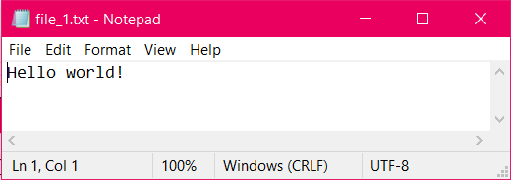

Extracted the encrypted file.